**HR Analytics Project**

**Introduction:**

This article in on the title ”HR Analytics Project- Understanding the Attrition in HR”, a project on machine learning which we will be doing in python. Human resource analytics (HR analytics) is an area in the field of analytics. It refers to the analyzing of the human resource department of an organization with an aim to improve the performance of the employees. We will be going through the entire steps that will be needed for the completion of the project and we will understand them thoroughly. The topics that we will be covering are:

* Problem Definition
* Data Analysis
* EDA Concluding Remarks
* Pre-Processing Pipeline
* Building Machine Learning models
* Concluding Remarks

**Problem Definition:**

HR Analytics in an area under the field of analytics which aims to provide insights into the processes of an organization by collecting the data and using it to analyze the performance of the organization in various fields and then finding ways to improve the performance.

Attrition in HR generally refers to the gradual loss of employees overtime. This is problematic for the organization, as this increases the expense of the company with the new hiring, paper works, and training the new employee. It also affects the company in way that an experienced employee is replaced with a new hire, who will take time to get used to the company and gain experience and errors are more likely to occur if you constantly have new workers. Also it is more concerning if the business is related to facing the customers, as customers feel more comfortable interacting with familiar faces.

Here, we need the help of machine learning to find a solution for this problem. We can use all the previous employee data of the organization along with the attrition data, i.e. If the worker had attrited or not. The data can then be feed into the machine and we can process the data and get an understanding on when and why workers choose to attrite and create a model that can predict using the new employee data that whether the person is likely to attrite or not.

**Data Analysis:**

The project provides us with a dataset that contains various employee data, for example age, department, field, working hours etc. And along with all this data we have the attrition data, whether the employee has attrited or not. We first import all the required libraries for the project and load the dataset into the notebook.

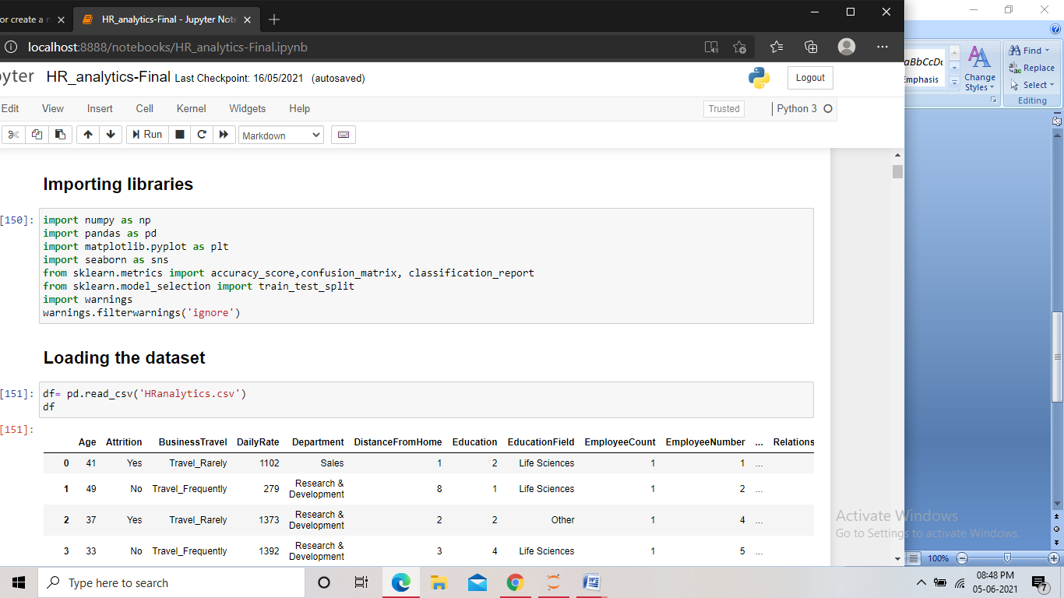

Screenshot of the code for importing the libraries

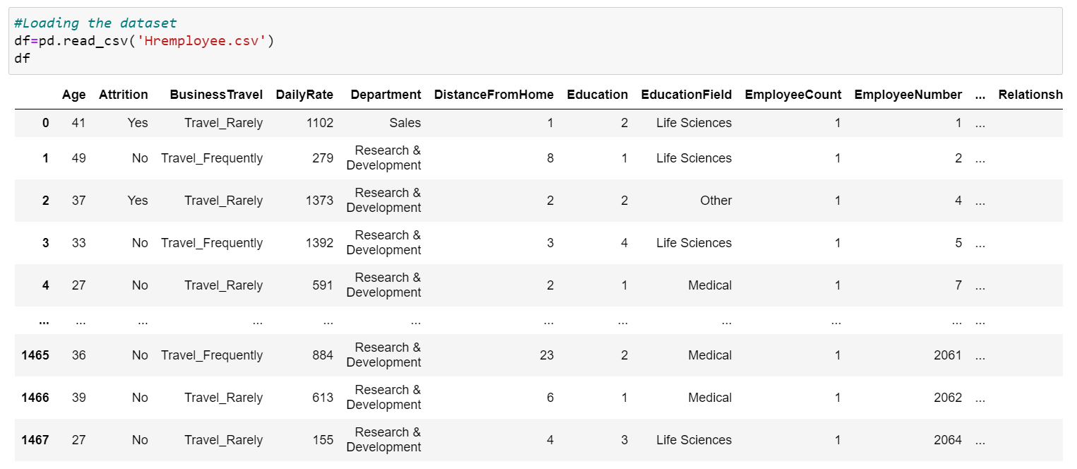

Screenshot of the dataset

The dataset is not that huge but contains many features, using which we have to build the model. The “Attrition” column is the target here. The target data has only two values that are yes or no, so it is clear that that the problem is a classification problem. We then check all the columns in the dataset.

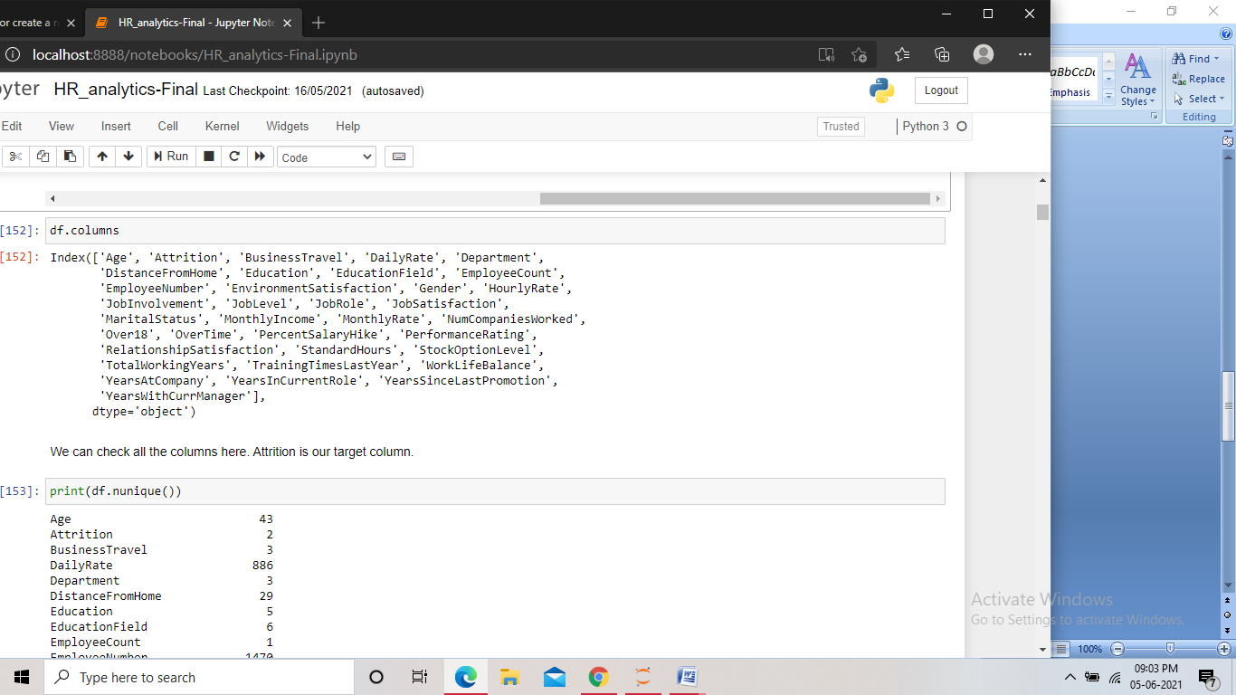

**EDA Concluding Remarks:**

* First of all we try to get an idea about the data present in the columns, we start by checking the number of unique values present in them.

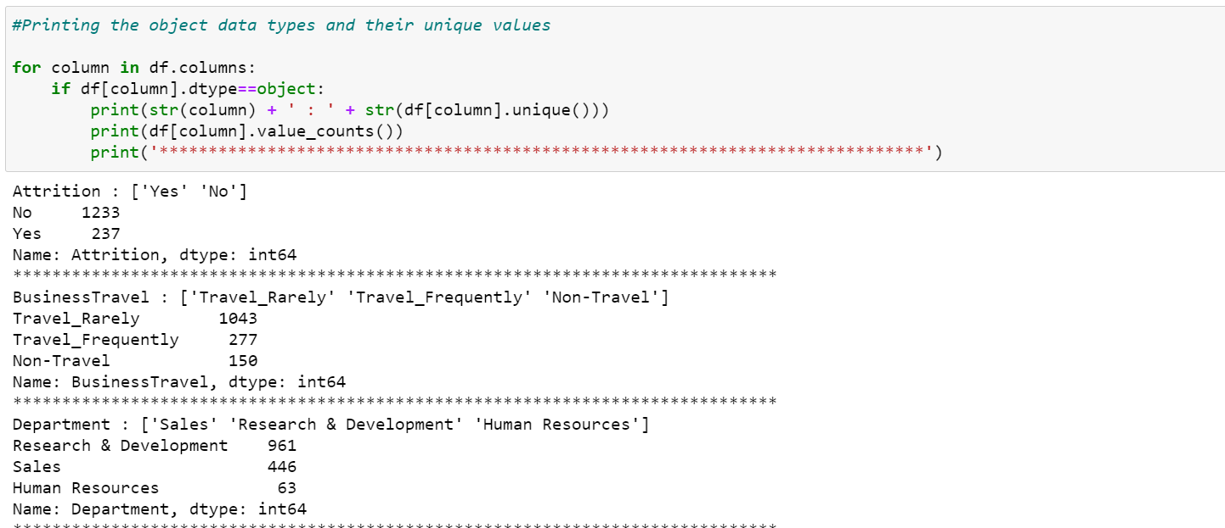

Screenshot of the code

Observation:

1-Out of 1470 only 416 employees doing overtime.

2-All employees are above 18 Years.

3-Out of 1470, 673 employees are married, 470 are single and 327 are divorced.

4-There are three departments: Sales, Research & Development, Human Resources.

5-Out of 1470 237 employees leave the company.

We found some columns having just one value for all the records. As these columns have no impact on the model creation, so we drop those columns.

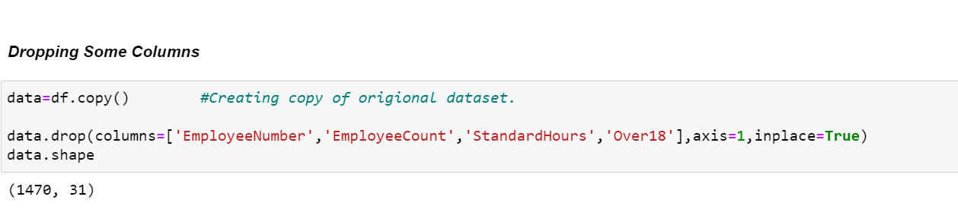

Screenshot of the code

* Now we check the shape of the dataset and also check if there are missing values present.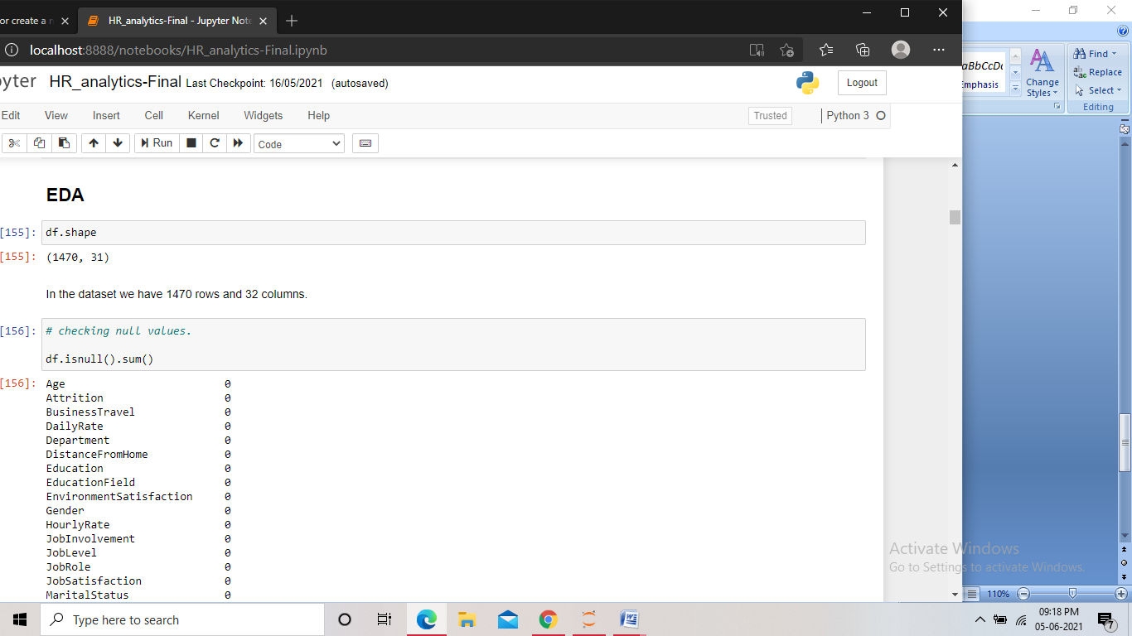

Screenshot of the code

The dataset then contained 1470 rows and 31 columns. Any by check for missing values we found none.

* After this we checked the data types of the columns. And the unique values present in them.

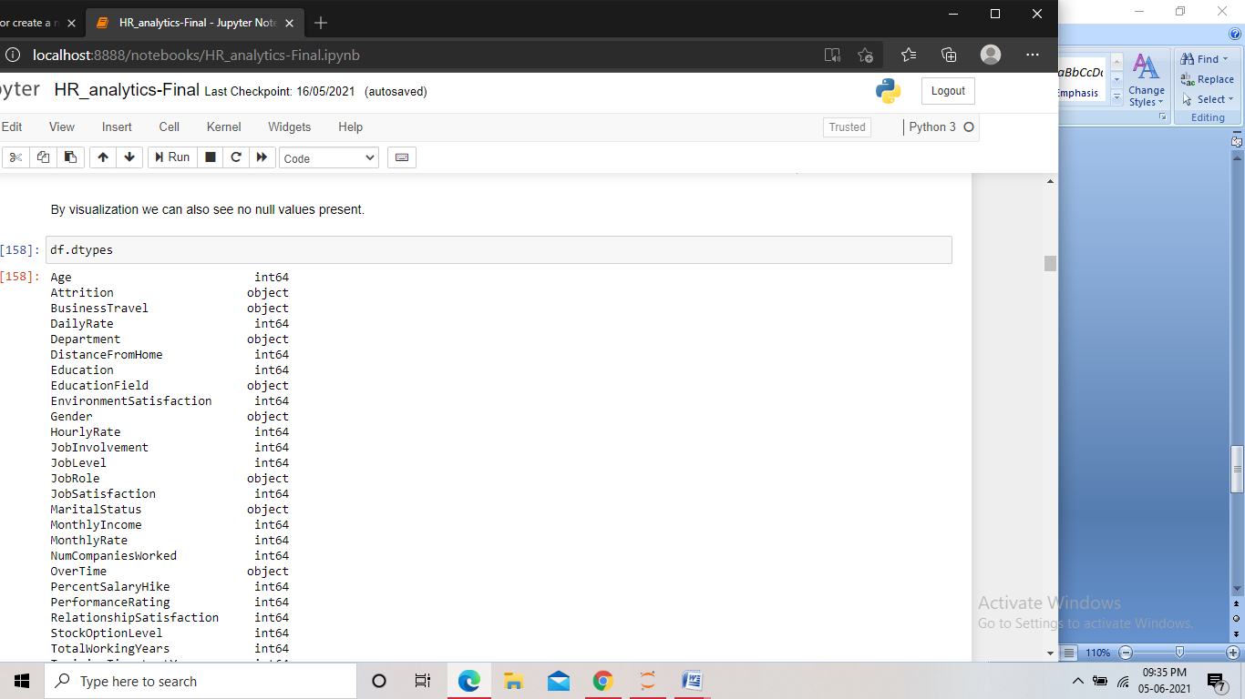

Screenshot of the code

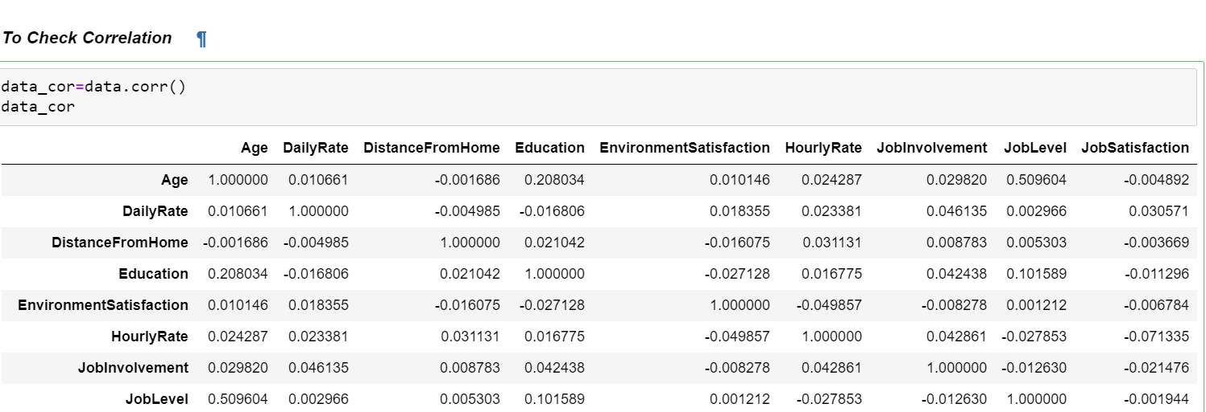

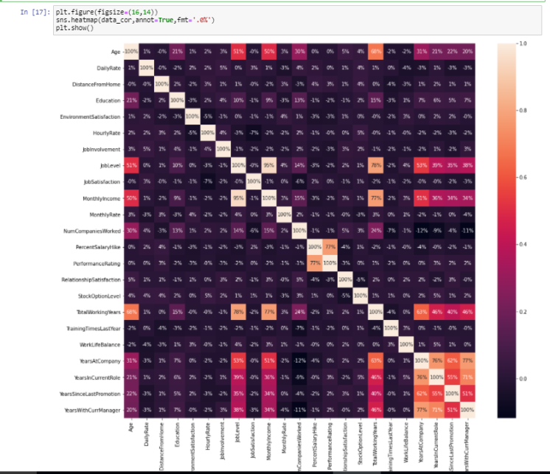

Observation:

1-Age is 68% correlated with TotalWorkingYears Because the longer you working at a job the older you are getting.

2-JobLevel is 78% correlated with TotalWorkingYears because the longer your work your job position is also getting higher.

3-MonthlyIncome is 77% correlated with TotalWorkingYears because the longer you work,the higher your income.

4-MonthlyIncome is 95% correlated with JobLevel because the higher your job level,the higher your monthly income.

We found that the majority of the columns contain categorical type value and many are in encoded format.

* We then checked the distribution of the data in the columns using different plots, and checked for class in the target column.

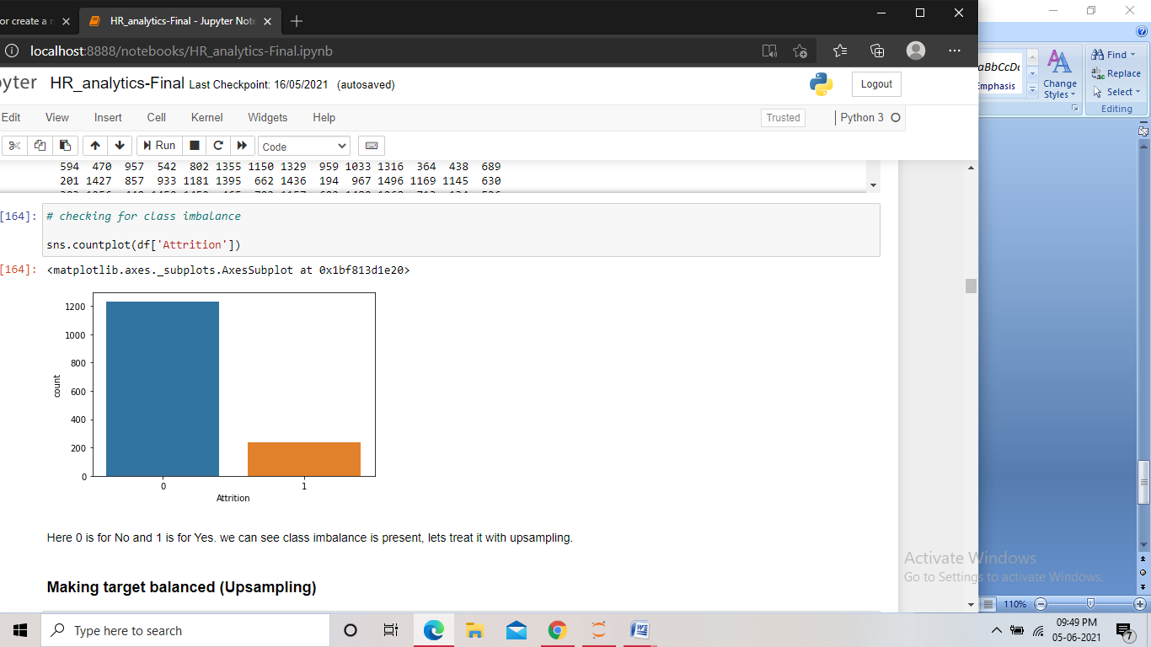

**Pre Processing Pipeline:**

With the EDA, we got the information about all the features in the dataset and found some issues in the dataset that needed to be treated.

* As we found many columns, including the target have the datatype as object, we encoded them so that we can proceed further.

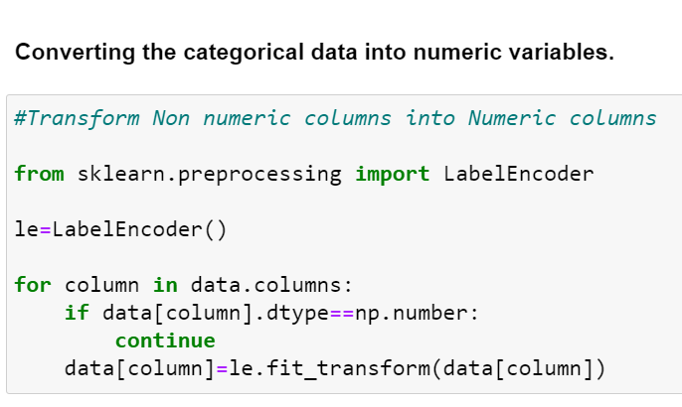

Screenshot of the code for encoding

Here we used the Label encoder for the encoding. We imported the encoder and assigned it to a variable and then using condition to select only the object datatype columns, we performed the encoding.

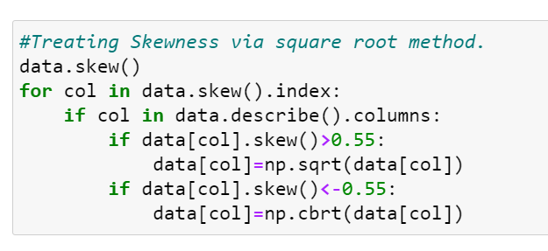

Taking the threshold of (>0.5 and <-0.5), some skewness were found in few columns, we then treated them.

**Removing Outliers**

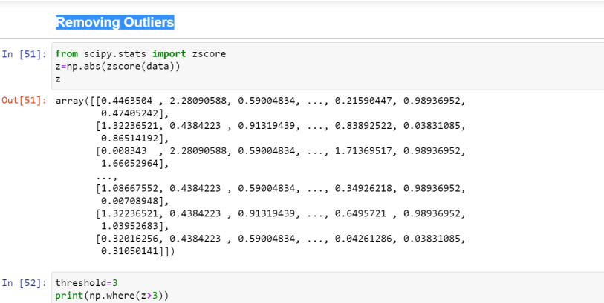

Screenshot of the code

At first we split the data into features and target and performed train-test split. We then imported the resample method. 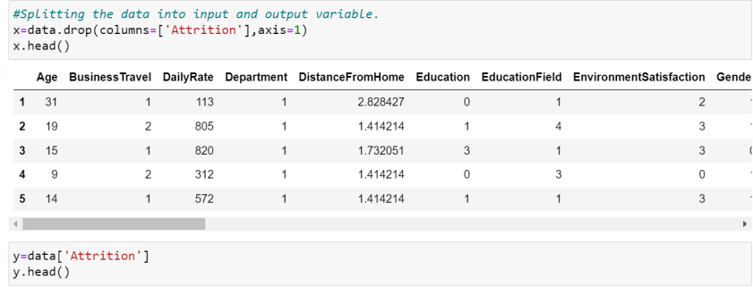

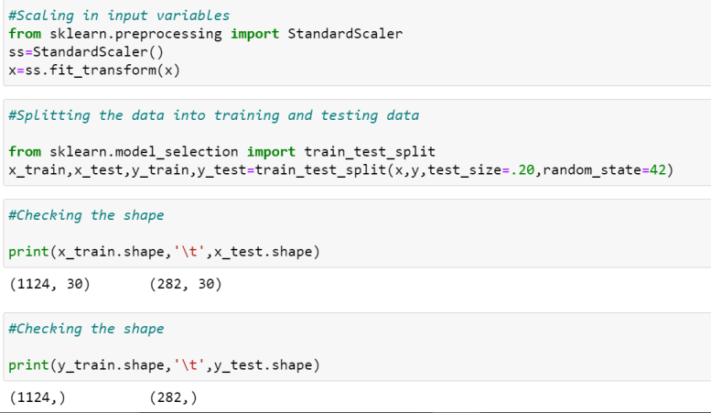

Scaling the features and splitting the data into train and test data

**Building Machine Learning Models:**

After the split we import different models from their libraries and assign them to a variable, then using the variable on the train data we perform the model fitting. After that we send the test features to the model for predicting the target and store the prediction in a variable. Finally we check the accuracy of the predictions by comparing the predicted and the actual target and then print the accuracy score. We also print the confusion matrix along with the classification report to get better understanding of the model performance.

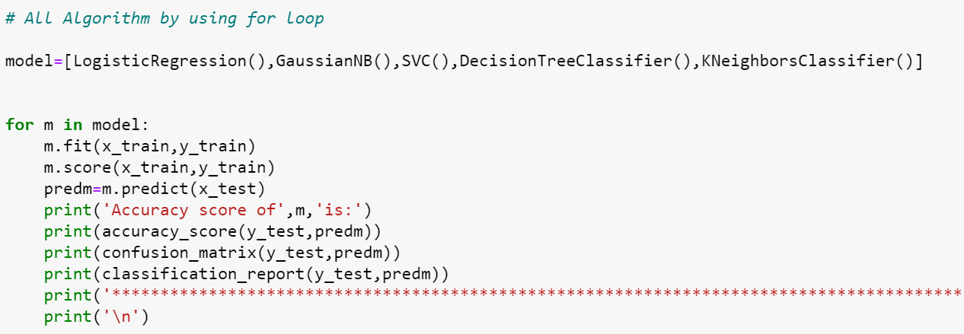

Screenshot of the code for logistic regression model

Using logistic regression model, we found an accuracy score of 89% and the f1 score of 94% for ‘no’ and 50% for ‘yes’.

For the Decision tree model, we got an accuracy score of 81% and the f1 score of 89% for ‘no’ and 42% for ‘yes’.

With the GaussianNB model, we got an accuracy score of 81.9% and the f1 score of 89% for ‘no’ and 48% for ‘yes’.

With the SVCmodel, we got an accuracy score of 96% and the f1 score of 97% for ‘no’ and 95% for ‘yes’.

With the KNeighborsClassifier, we got an accuracy score of 87% and the f1 score of 93% for ‘no’ and 32% for ‘yes’.

* A good score may be due to the overfitting of the model, and therefore we checked the cross validation score for all the models for any over fitting or under fitting problem.

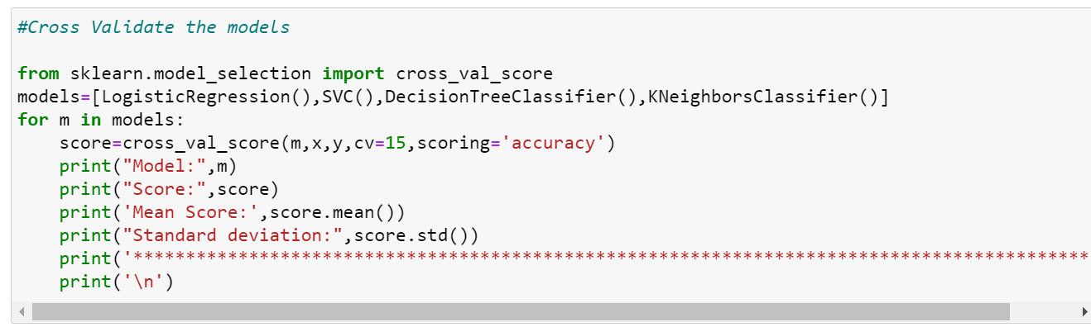

Screenshot of the code

### Above all models SVC is giving best result.

* Now, as SVC showed a good performance, we then hyper parameter tune the models and find the best performing using Gridsearchcv.

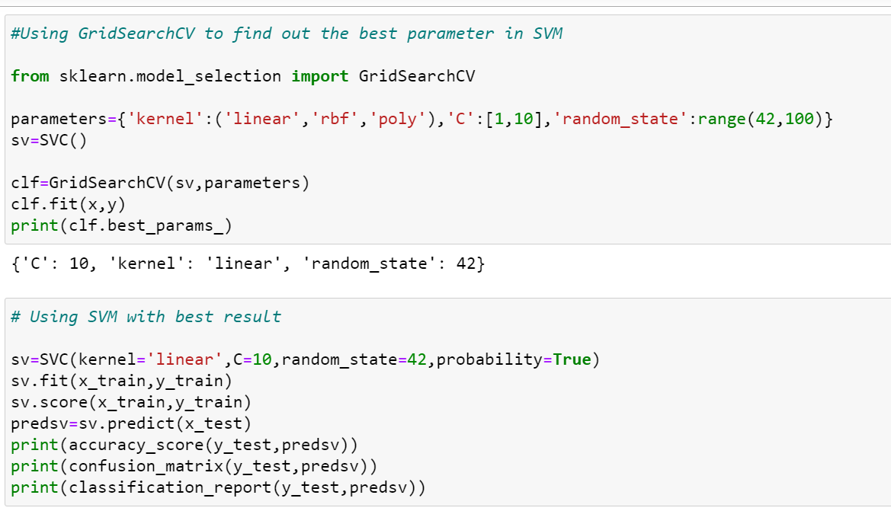

Screenshot of the code for hyperparameter tuning Decision tree

We imported GridSearchCV and passed different attributes with its different parameters to it along with the model, and we got the best parameters for the model. Then using those parameters we created our model.

.

* As this was a classification problem, we then checked the AUC ROC curve, Confusion matrix

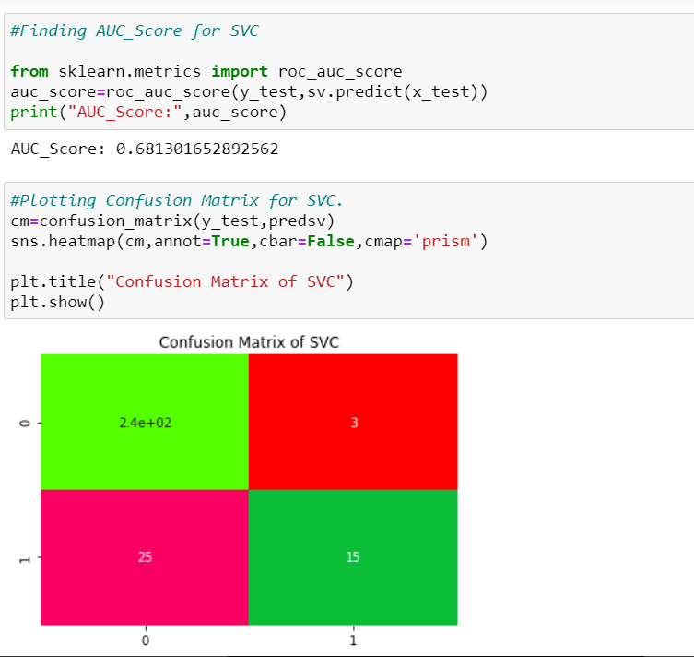

First we imported the plot and fed the model to it, and we got the area under the curve as 90%.

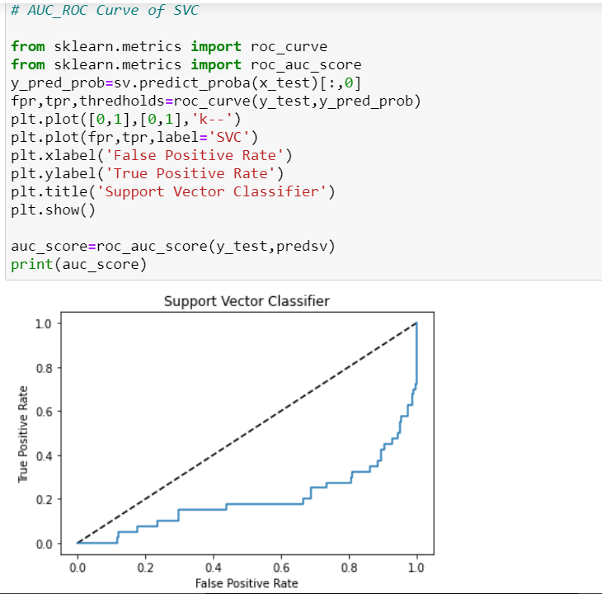

* Analyzing both the model’s performance, we found that the SVC model was performing better. Hence we made the former our final model and then saved the model.

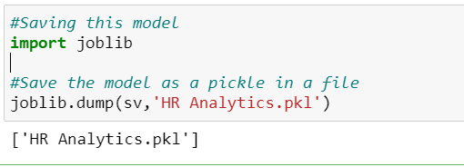

Screenshot of the code for saving the model

Finally we imported joblib and saved the model in pkl format.

**Concluding Remarks:**

With this project, we got the idea about what type of data we can work with in building a model and what type data we should avoid. We also found how balancing the target values in a classification problem play a crucial part.

By analyzing the dataset provided in this project, we found that the attrition has a high positive correlation with overtime, as overtime increases chances of attrition also increases. We also found that attrition has a negative correlation with the job level and monthly income, which meant that with a higher job level and a monthly income, the chance of attrition goes down.

We found how tuning the right parameters increase the performance of the model, and saw role of ROC curve in analyzing the performance and finalizing a model in a classification problem.